**Kolt 45 Mastery Challenge**

Kolt 45 Mastery Challenge is an app that allows you to battle your friends for ultimate bragging rights. Choose a champion to race to see who can get the most amount of points in a given amount of time. Find a summoner to challenge, send them a challenge and when they accept, you’re off to the fight. Achievements are awarded to the victor. This app is currently in concept stages

**Landing Page**

You’ll land on the site and be immediately fired up by everyone’s least favorite champ. Log in and begin a challenge

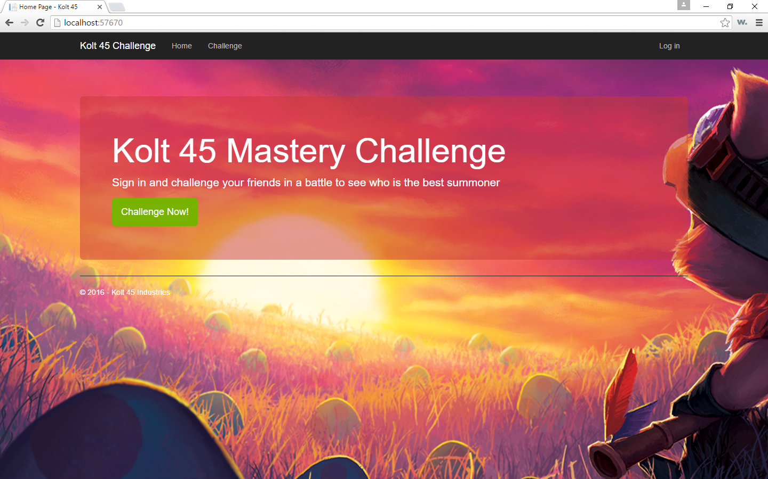

**Login Page**

Login if you have an existing account or create a new one if you don’t have one

Logins can be tied to one summoner. If a summoner is already linked to an account, it will not be abllow to be created

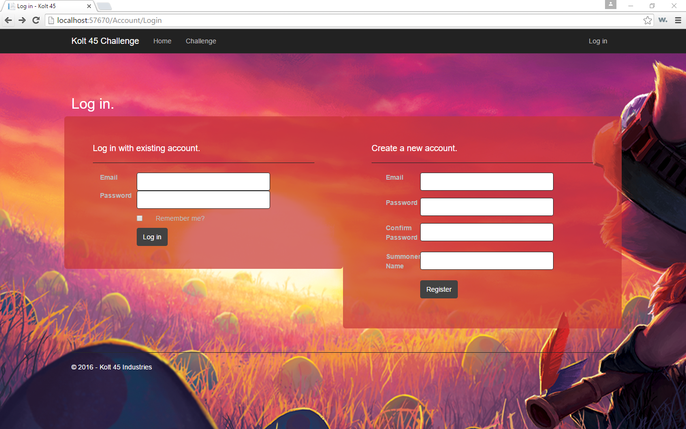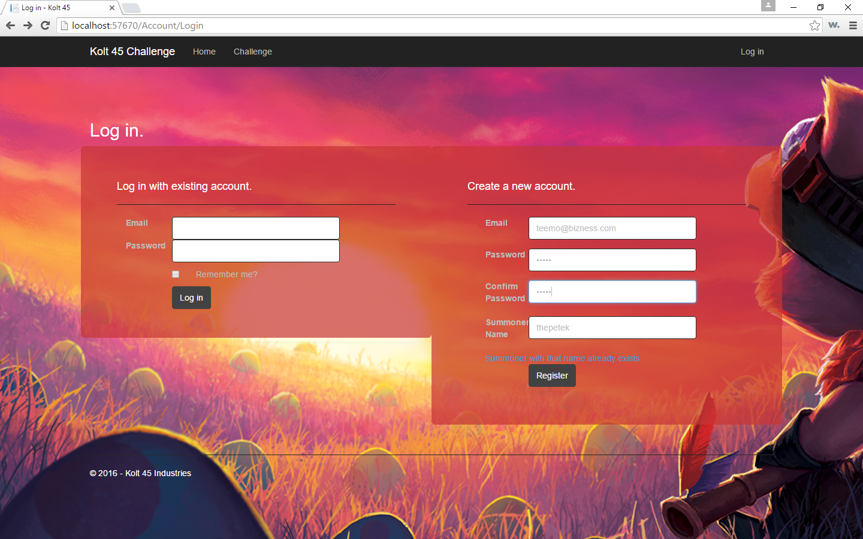

**Challenge Page**

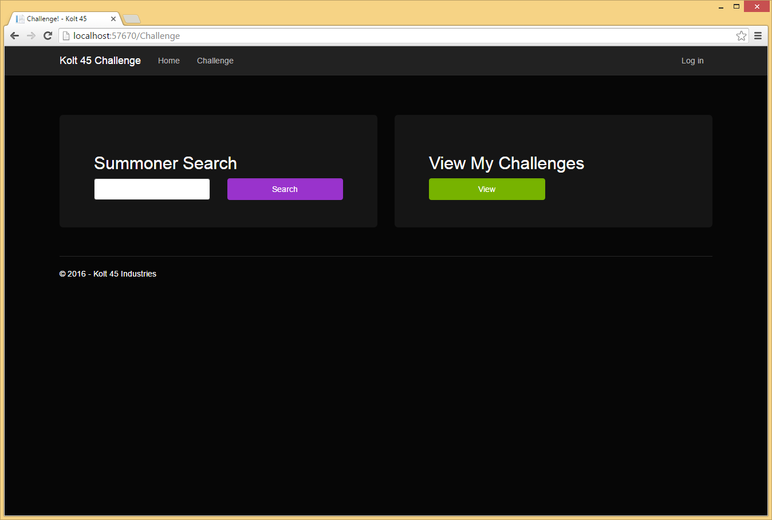

When you get to the challenge page, you can search for a summoner to challenge or view any current challenges that you may be participating in.

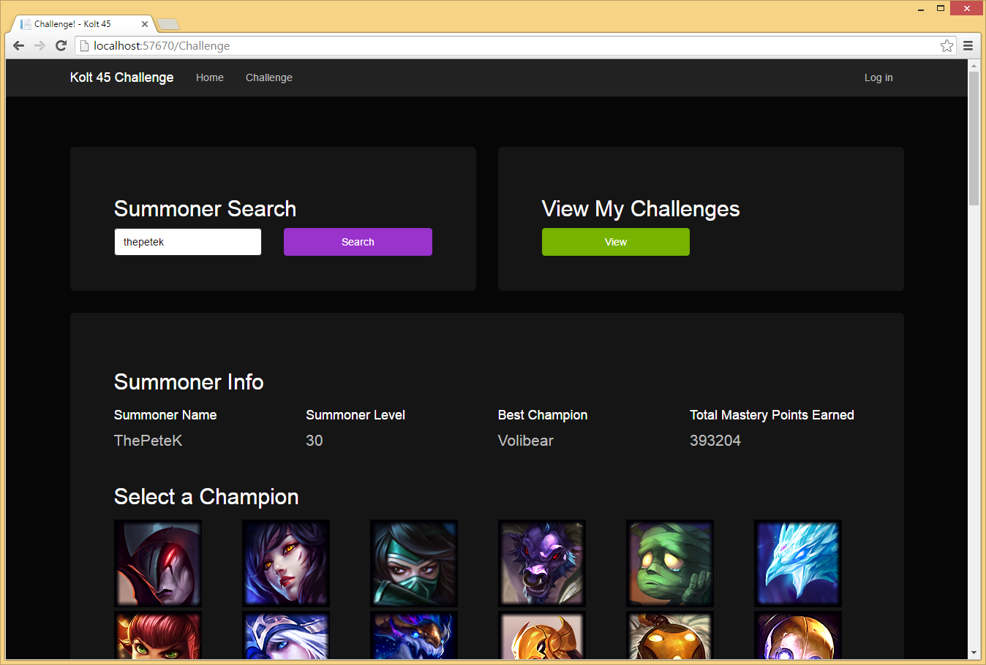

When you search for a summoner you can see their mastery level on all the current champions. You’ll see their best champ and then be able to choose any champion to challenge. There is no limit on which champions you can challenge on as this is a race to see who can earn the most points in a given amount of time.

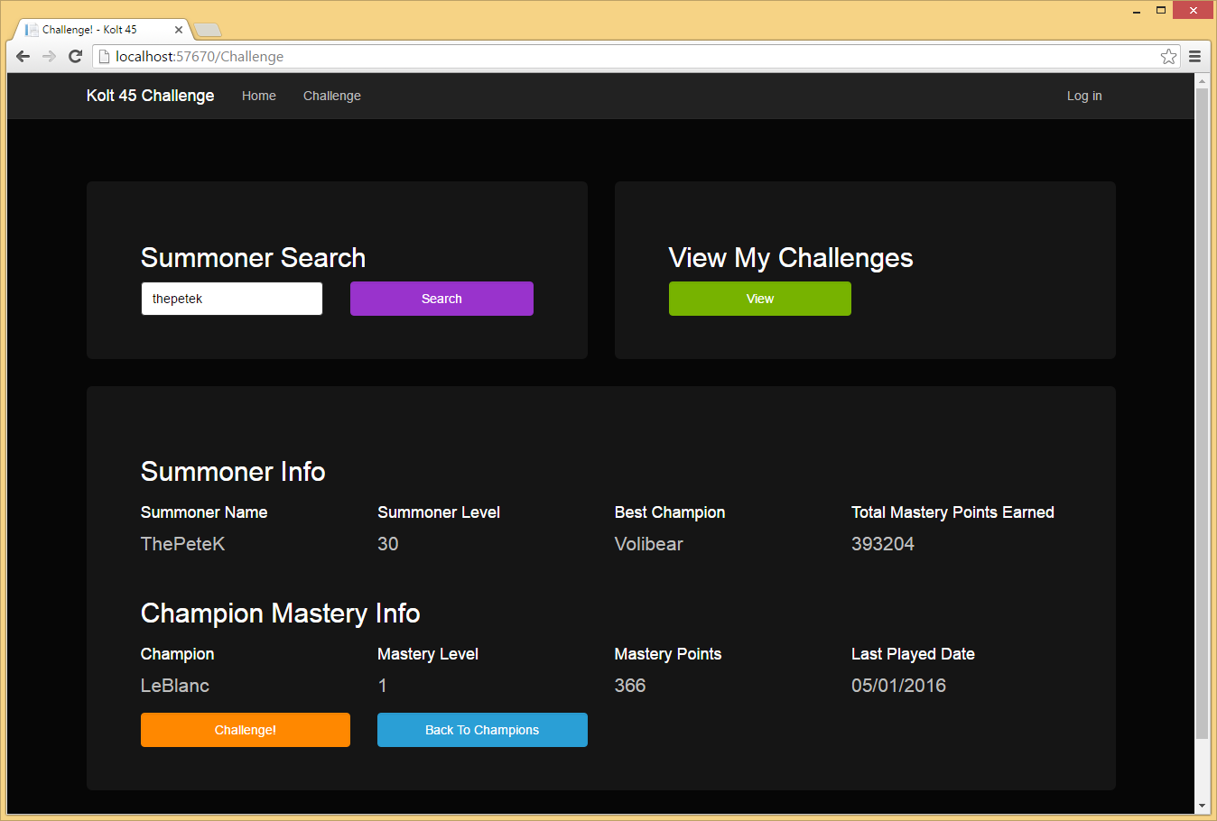

Once you choose a champion, click challenge to challenge your opponent.

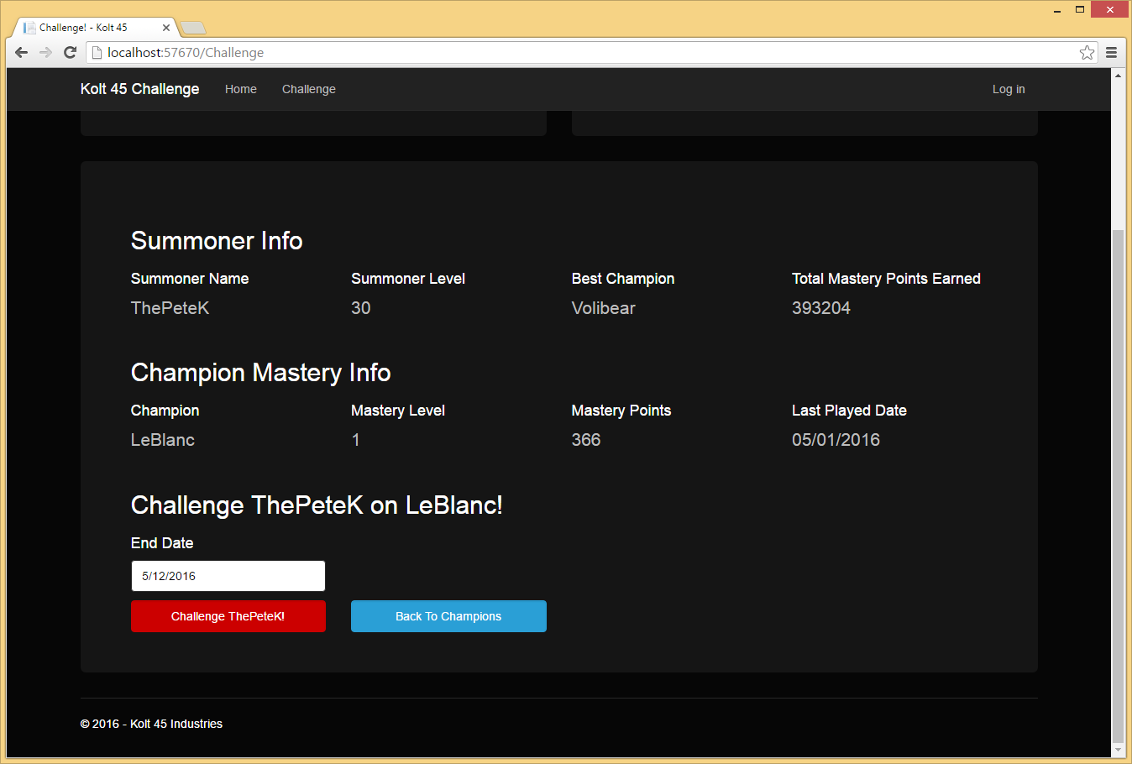

When you challenge, set the end date. Whoever earns the most points in the time arranged, wins and gets all the bragging rights.

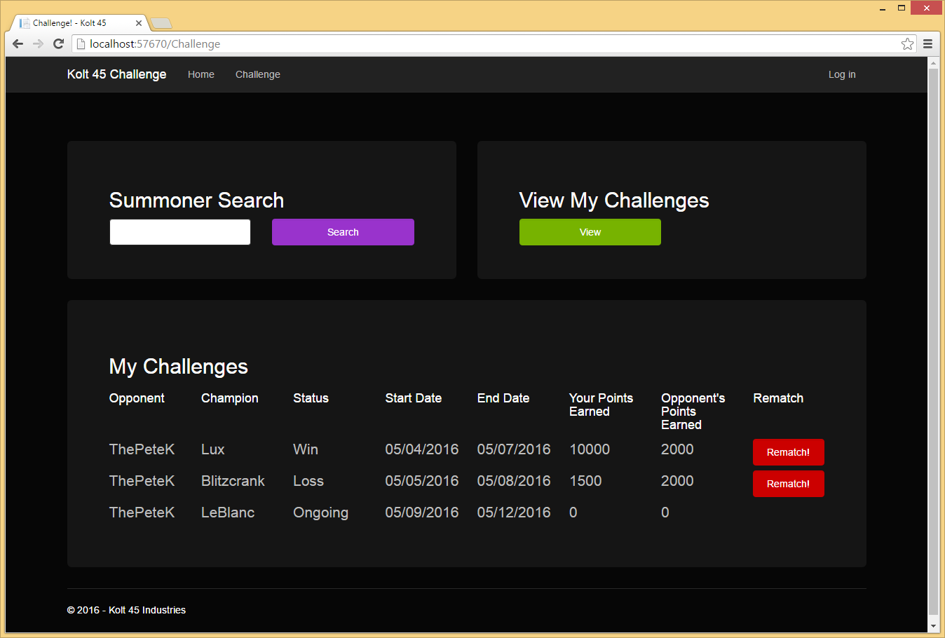

Finally you can view all your current challenges and your historic challenges and see the results.